DAY 5 - 15.04.2024

EMPLOYEE OBJECT - CRUD OPERATION (USING ARRAY) SCREENSHOTS

1. ADDING EMPLOYEE AND PRINTING EMPLOYEE DETAILS

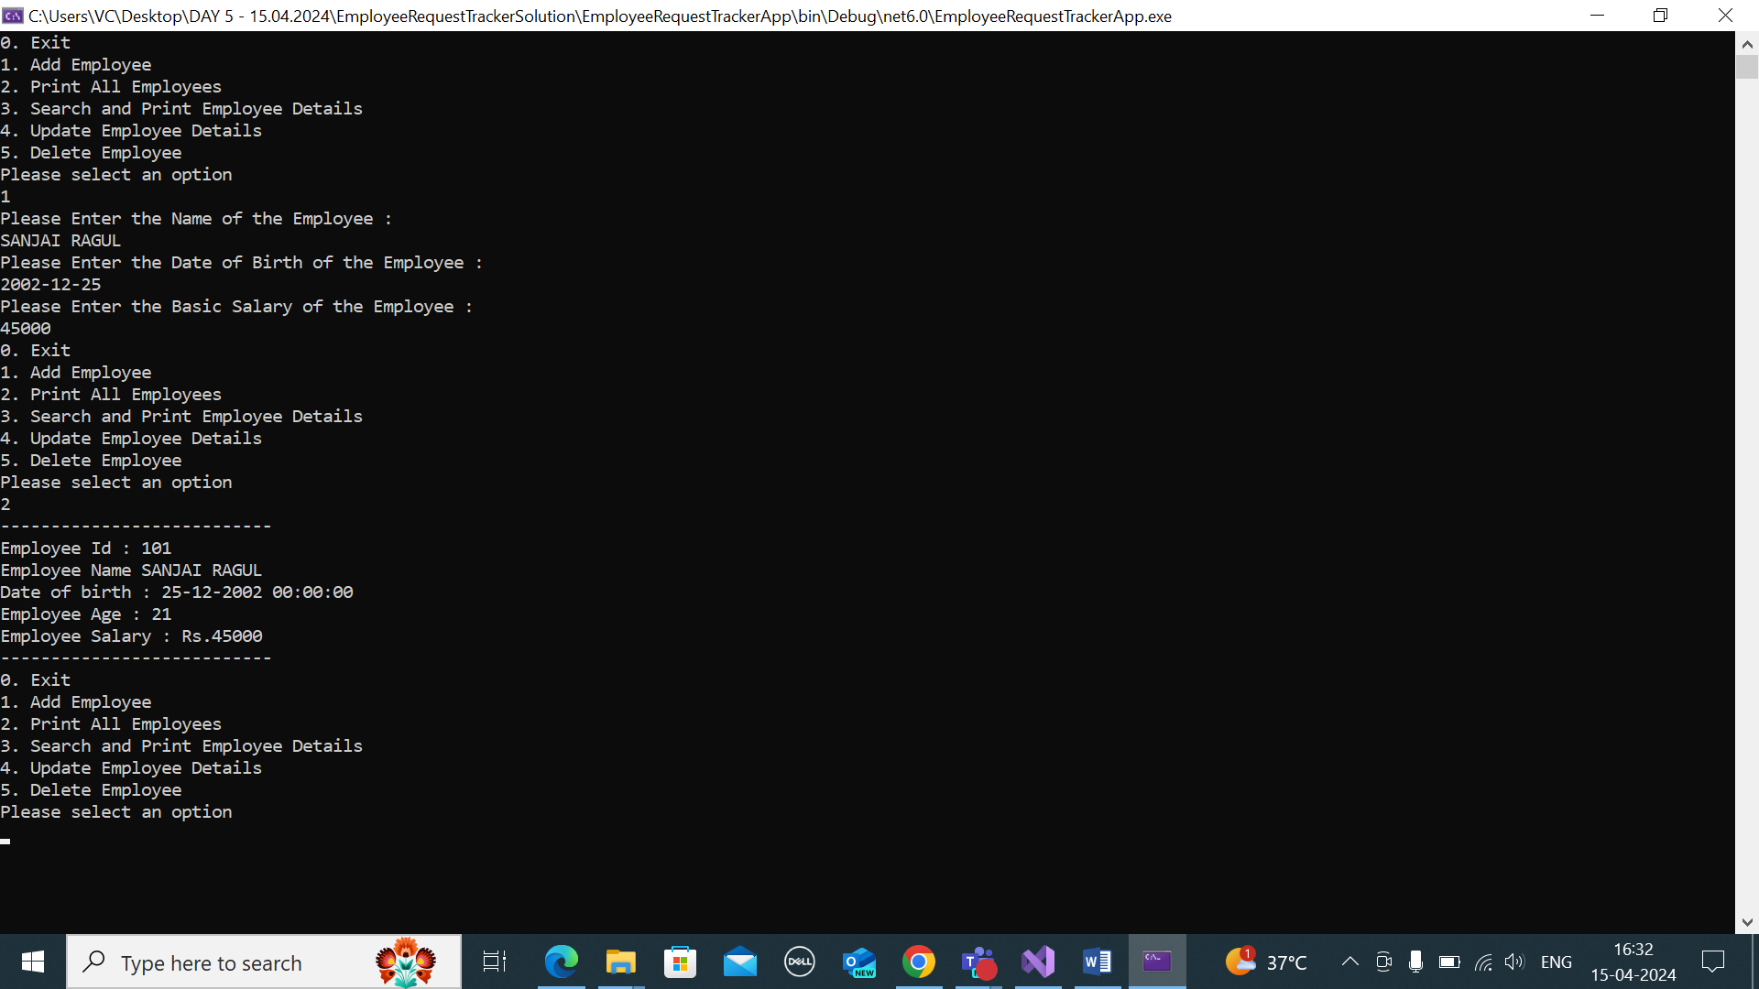

1. SEARCHING AND PRINTING EMPLOYEE DETAILS IF AVAILABLE (ID SEARCH – EMPLOYEE AVAILBLE)

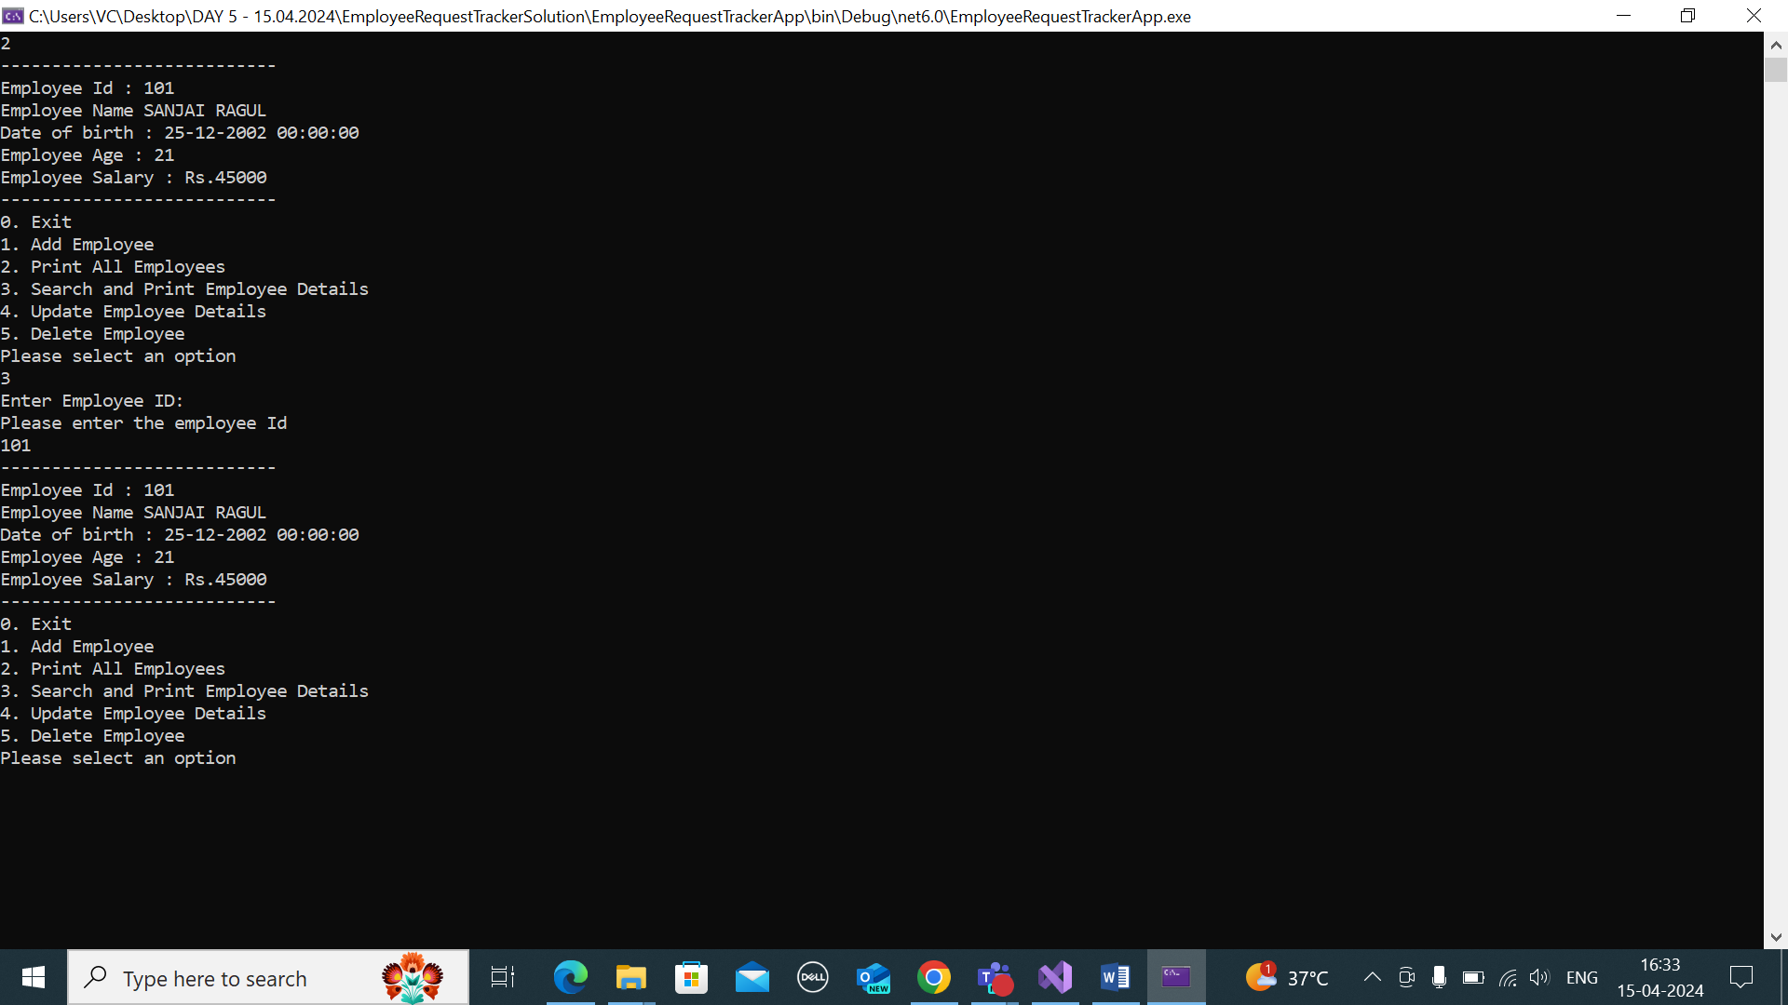

1. ID SEARCH – NO EMPLOYEE AVAILABEL

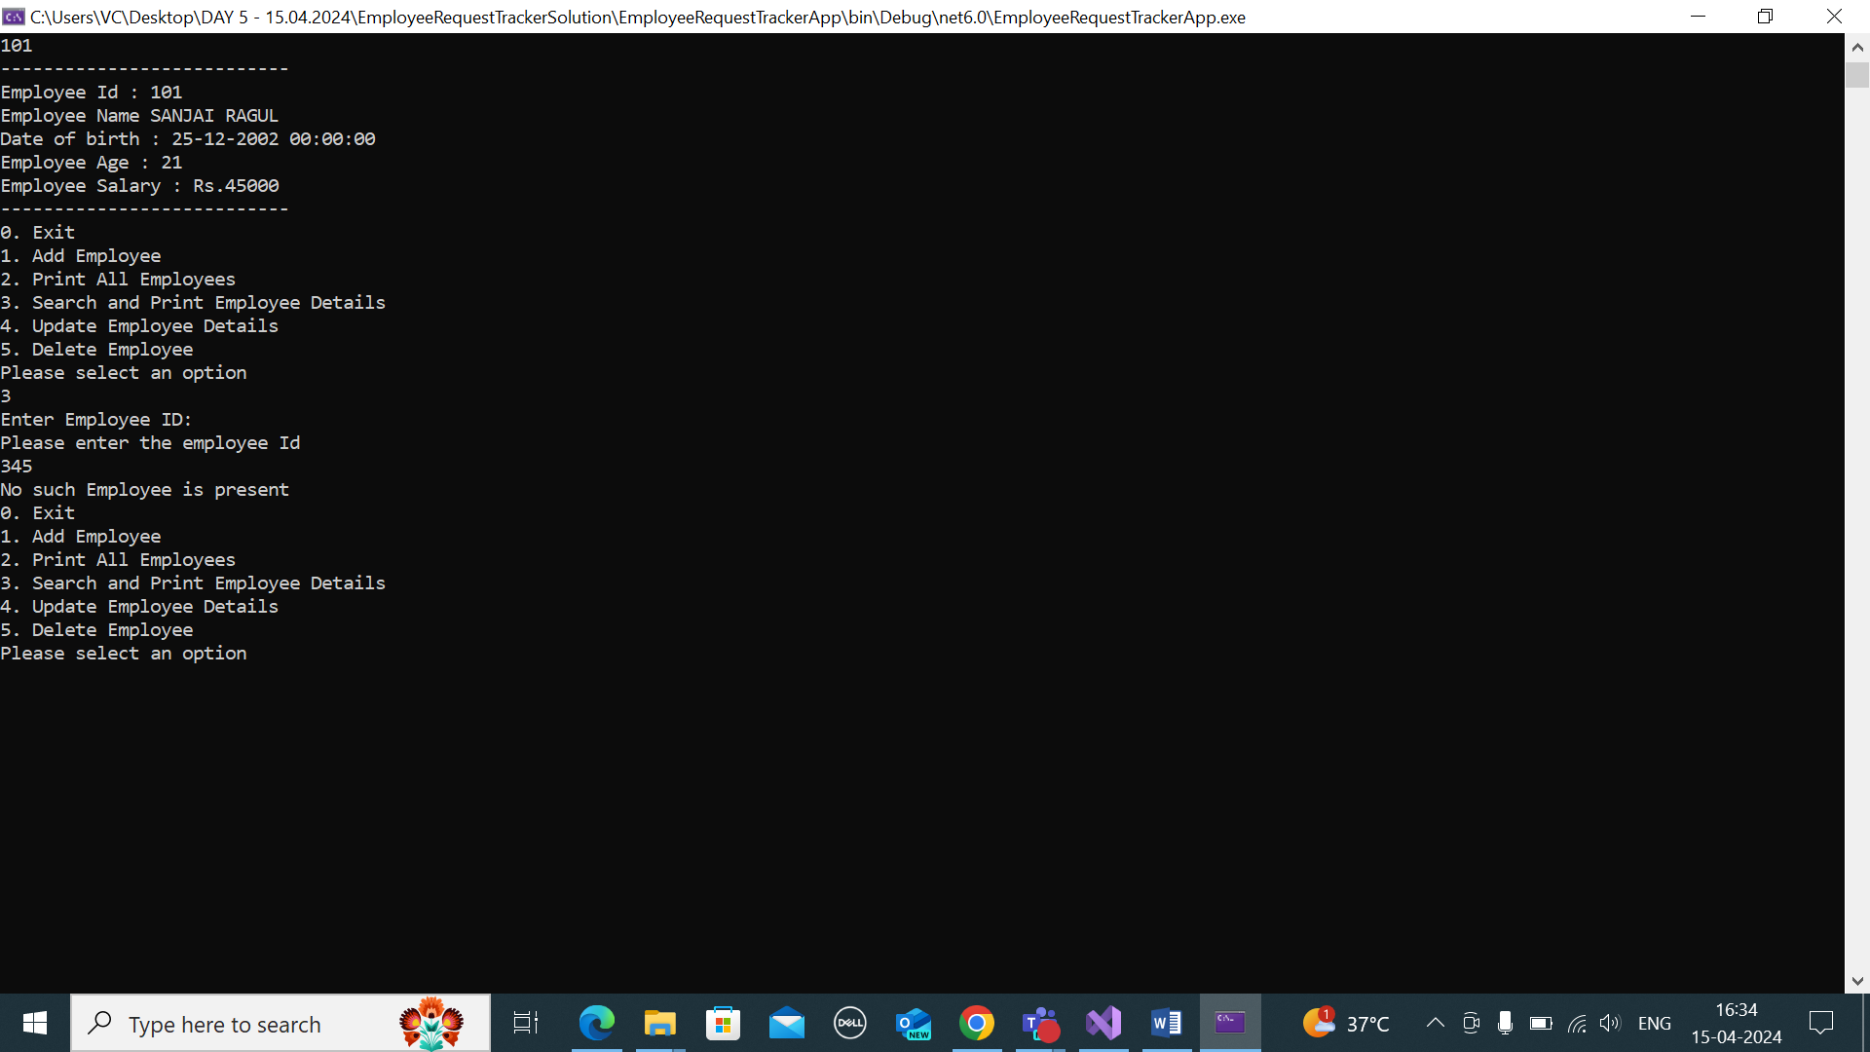

1. UPDATING EMPLOYEE NAME AND PRINTING THE UPDATED EMPLOYEE DETAILS

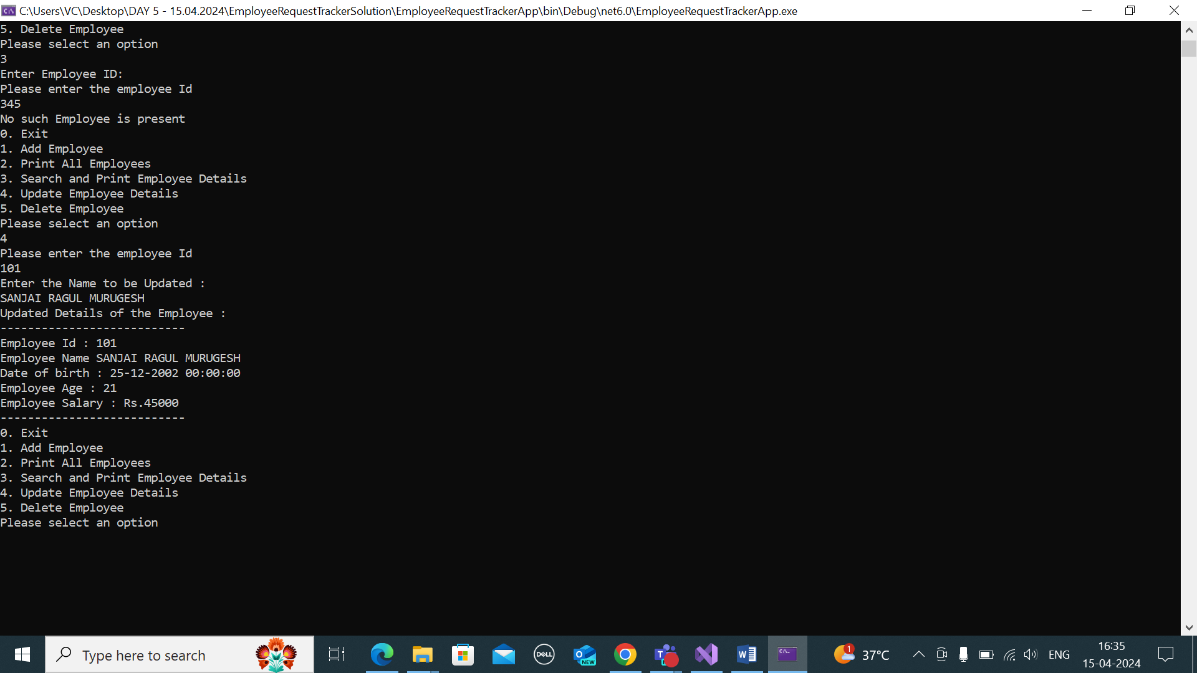

1. DELETING EMPLOYEE AND PRITING THE REMAINING EMPLOYEE DETAILS

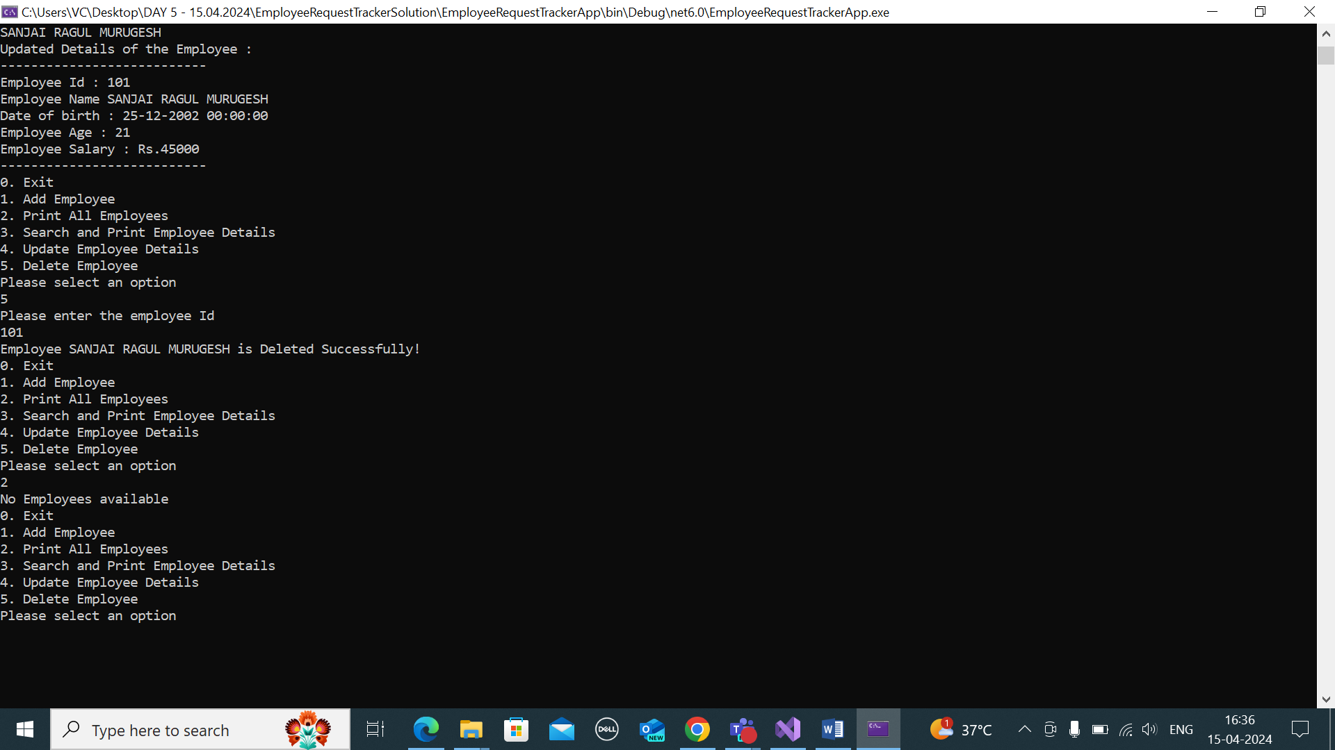

1. ADDING 2+ EMPLOYEES AND PRITING THE EMPLOYESS AVAILBLE

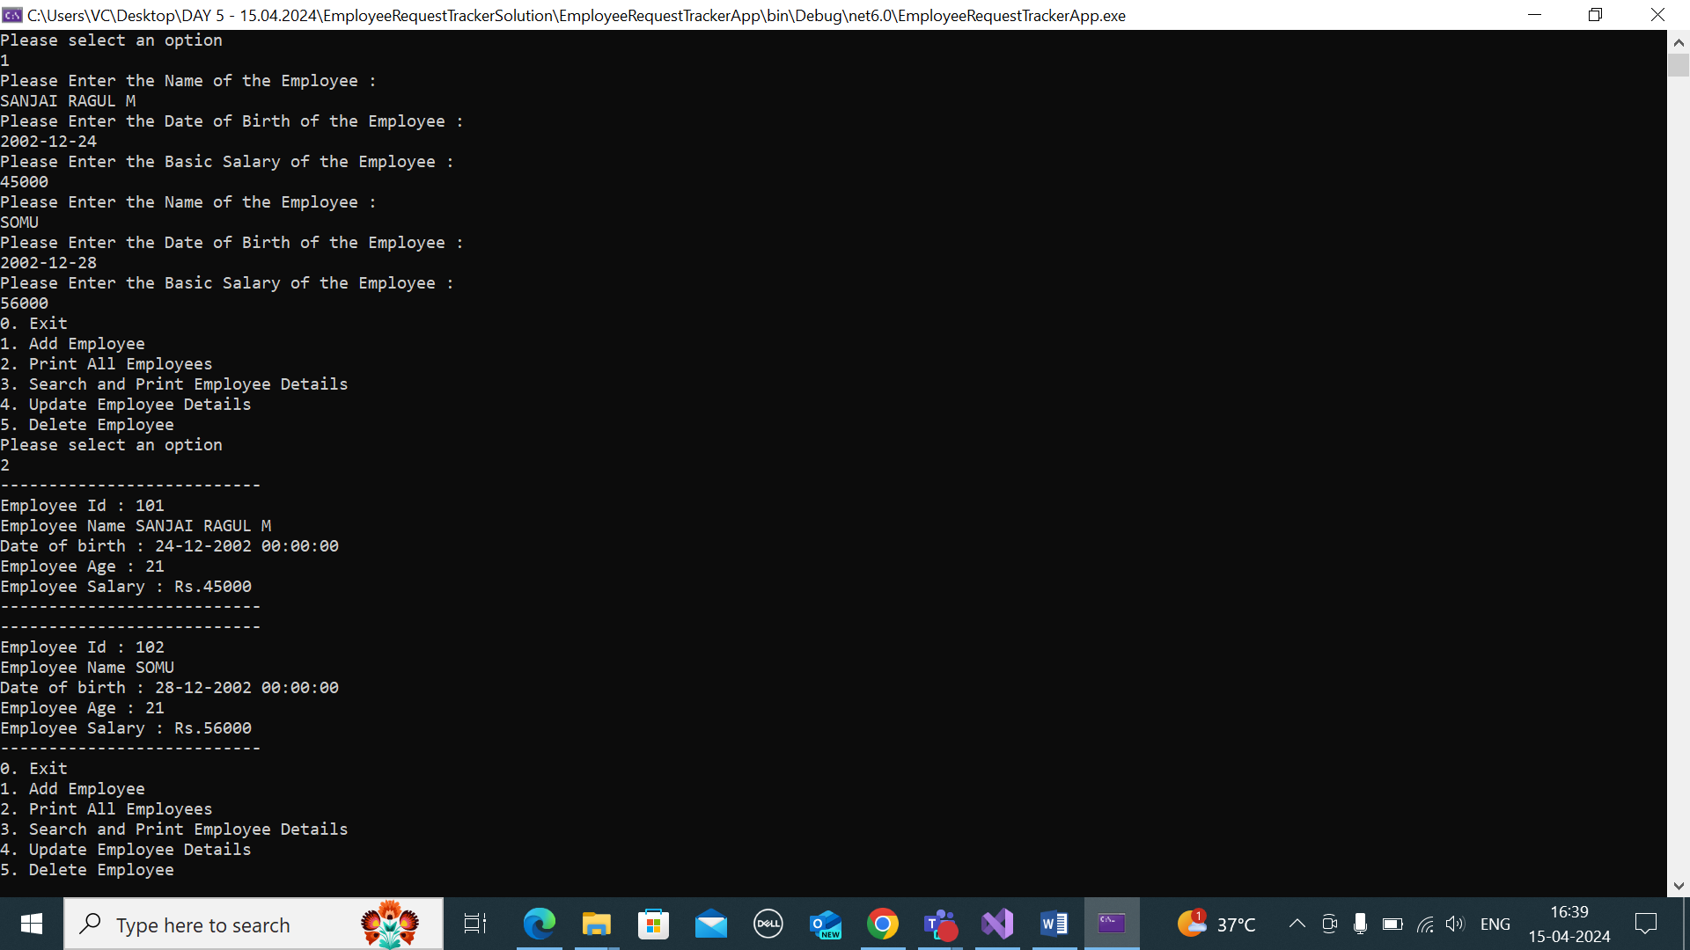

COW BULL PROBLEM

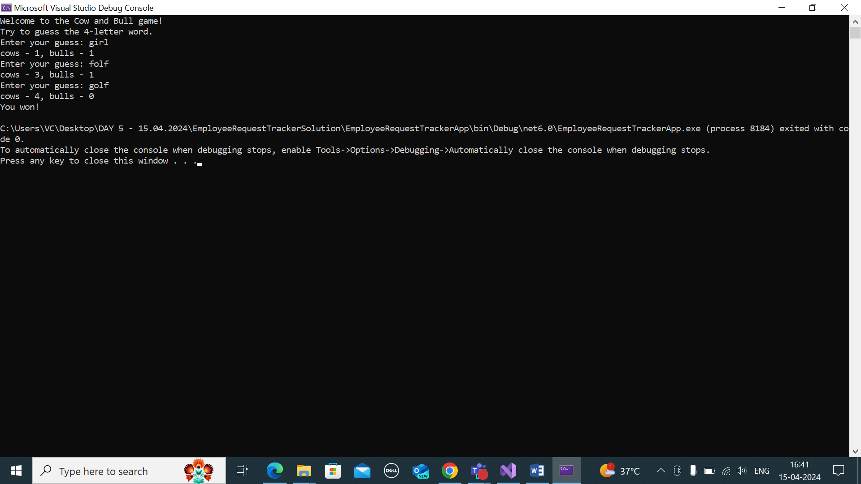

UNDERSTANDING SEQUENCE STATEMENTS:

IF ELSE IF ELSE :

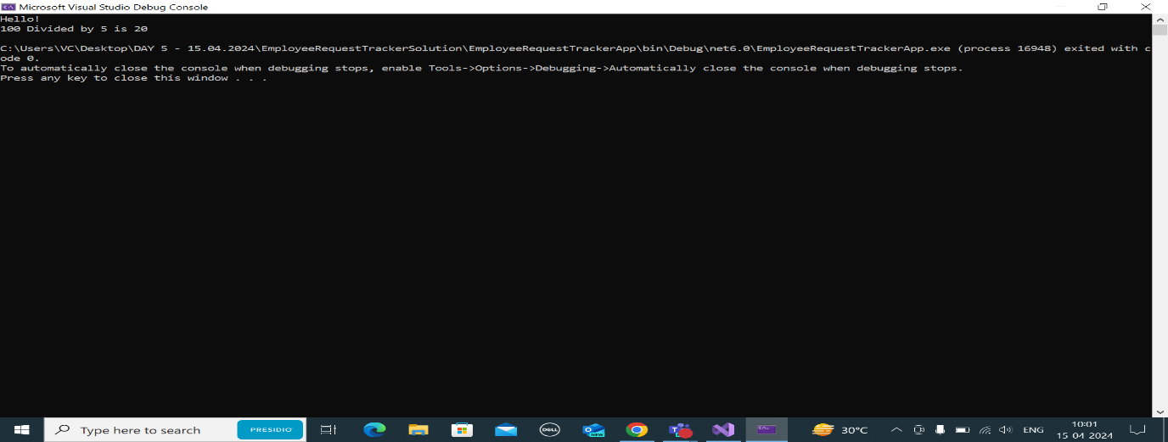

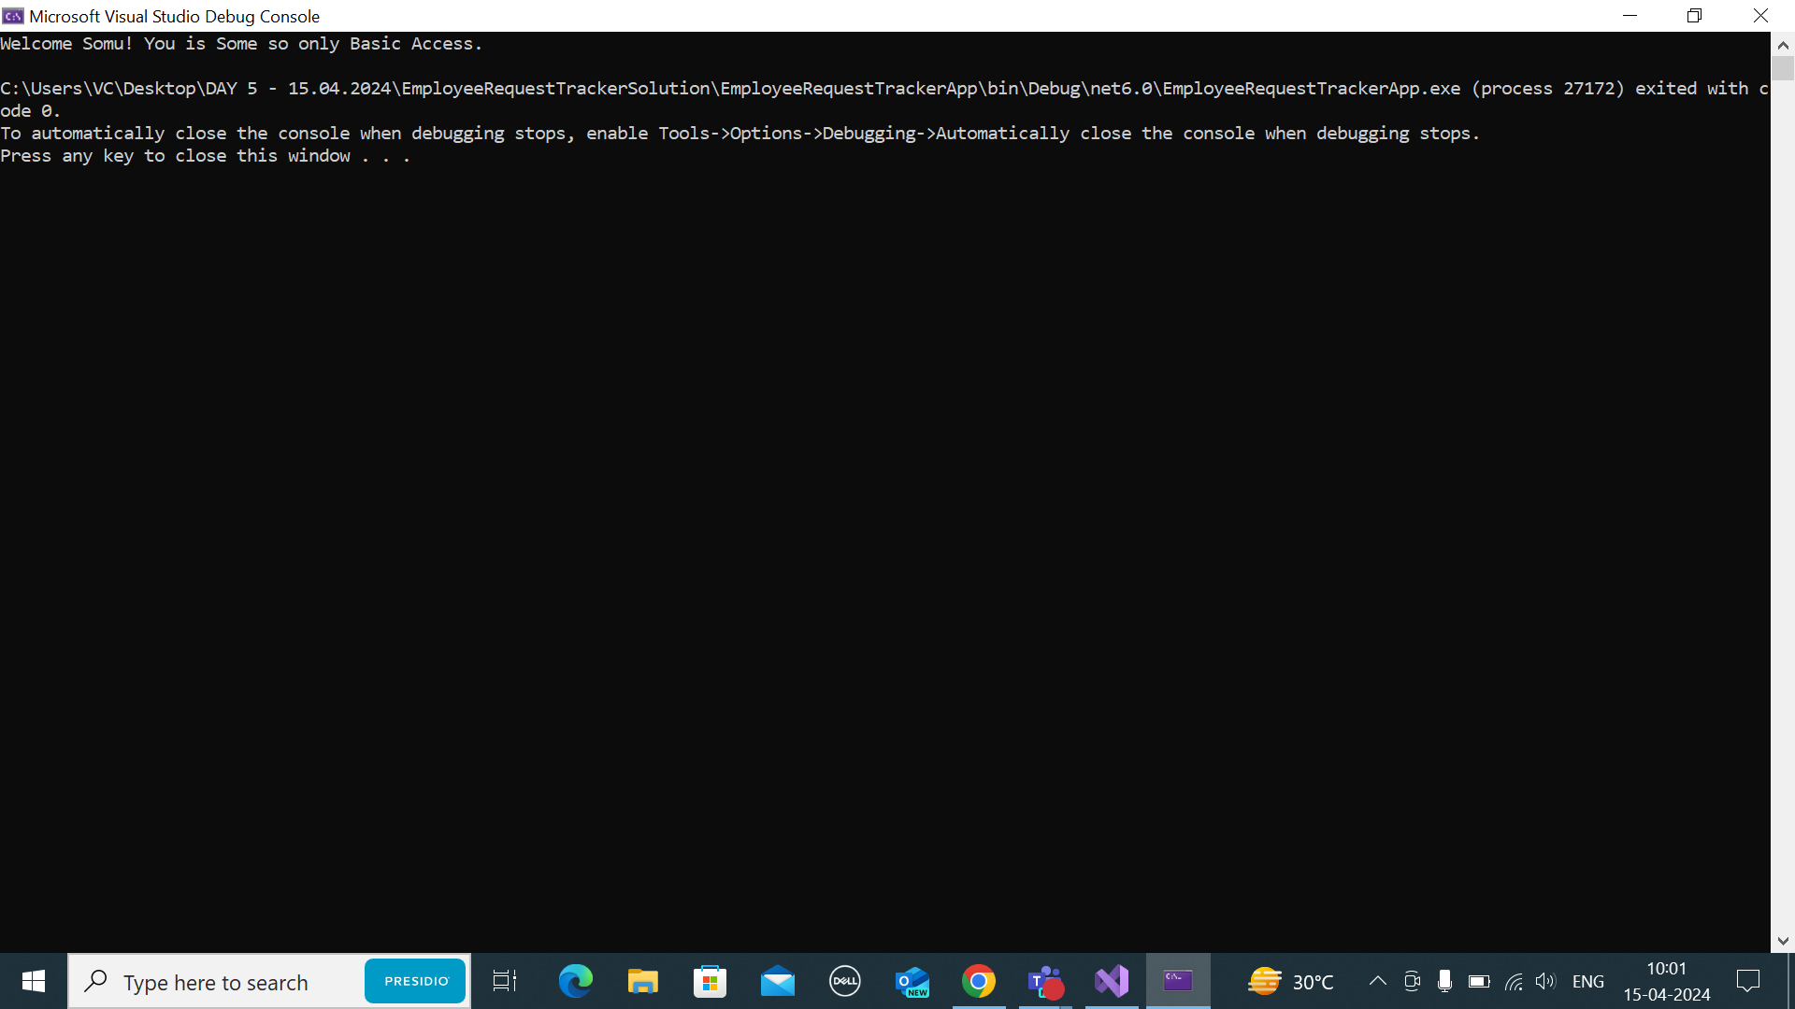

SWITCH STATEMENTS :

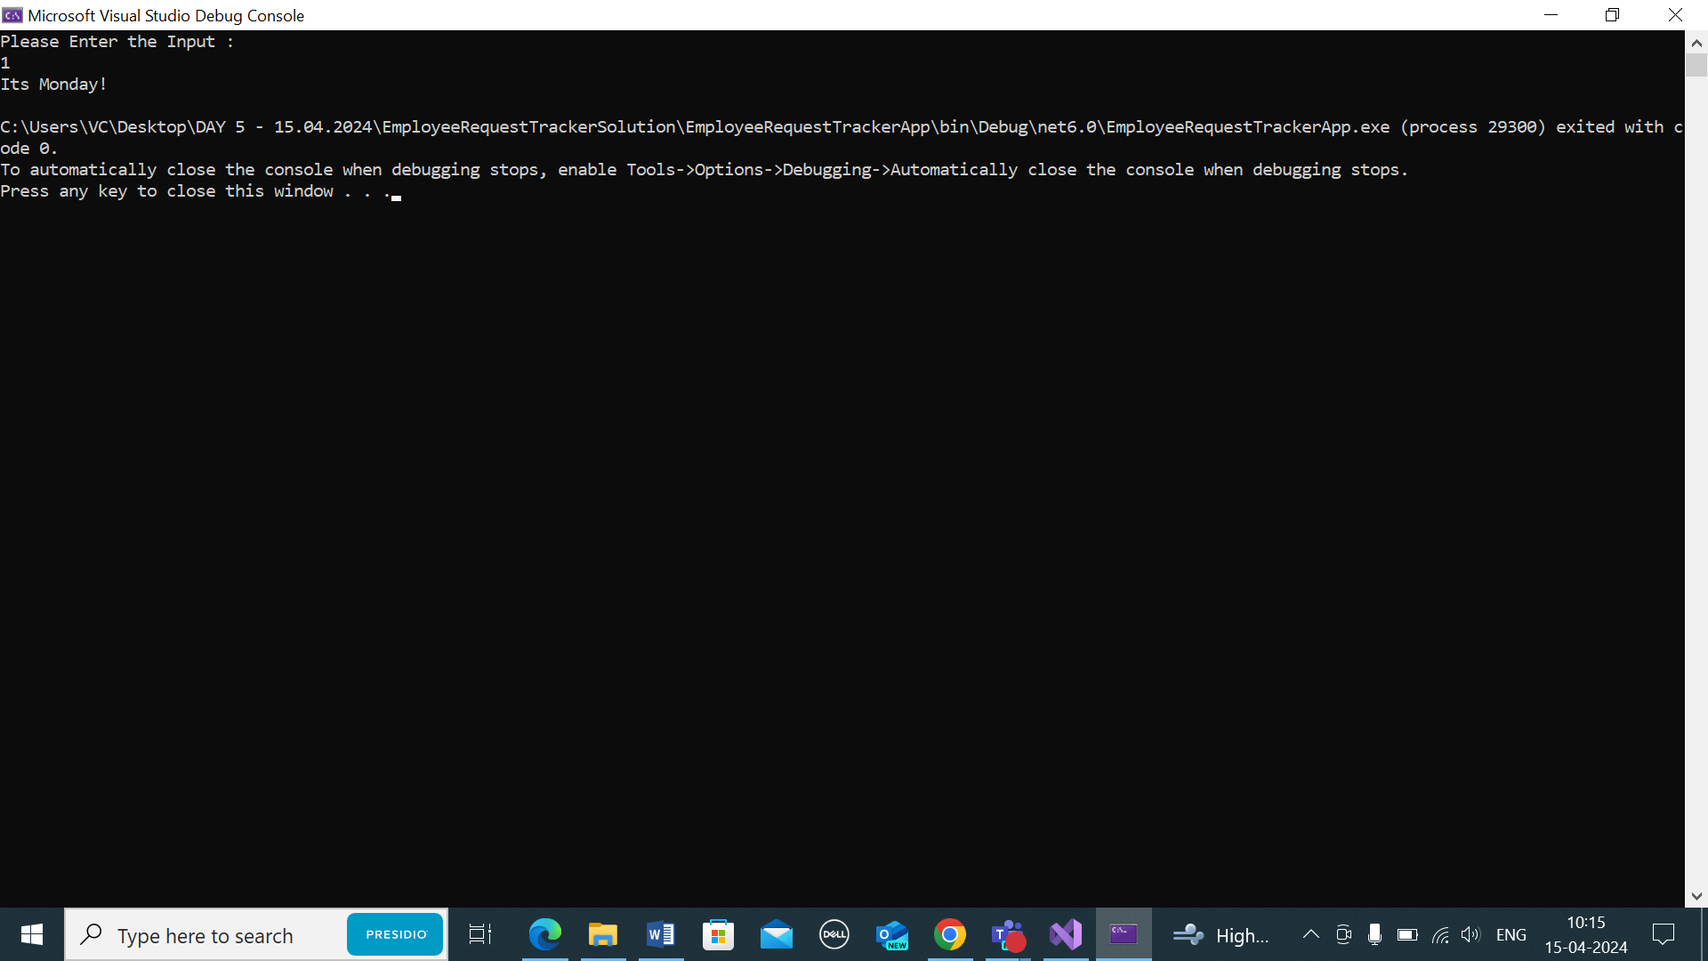

WHILE:

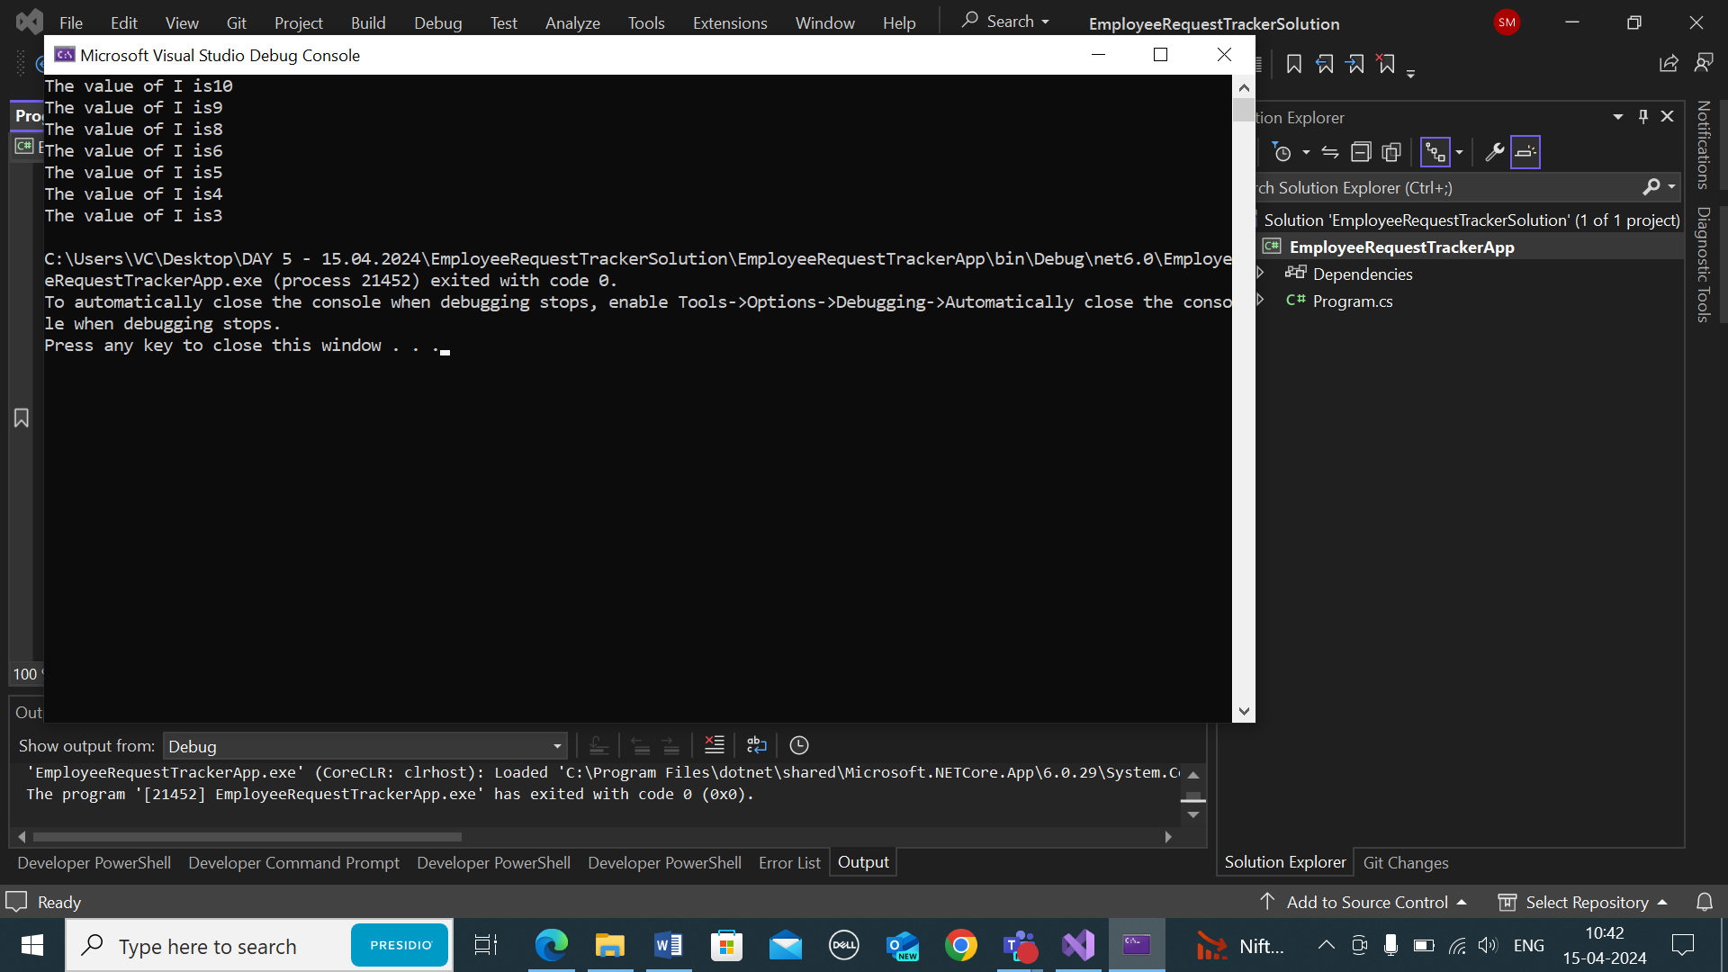

FOR LOOP:

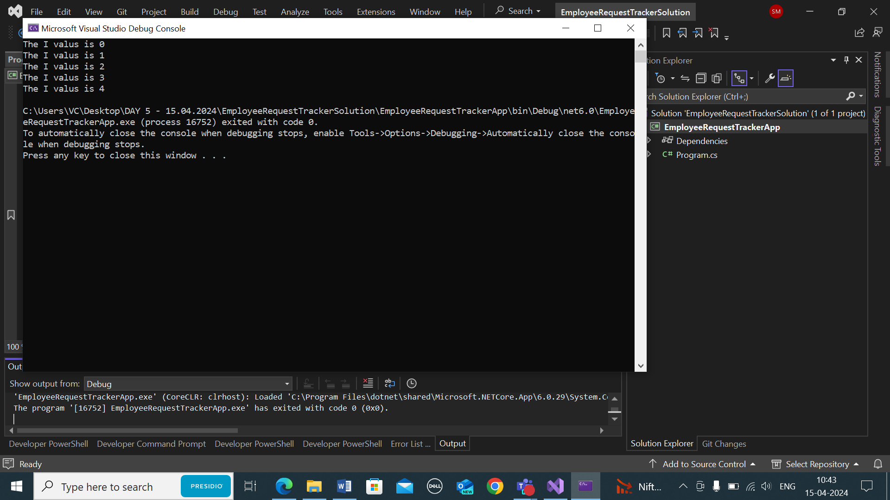

ARRAY AND REPEATING DIGITS:

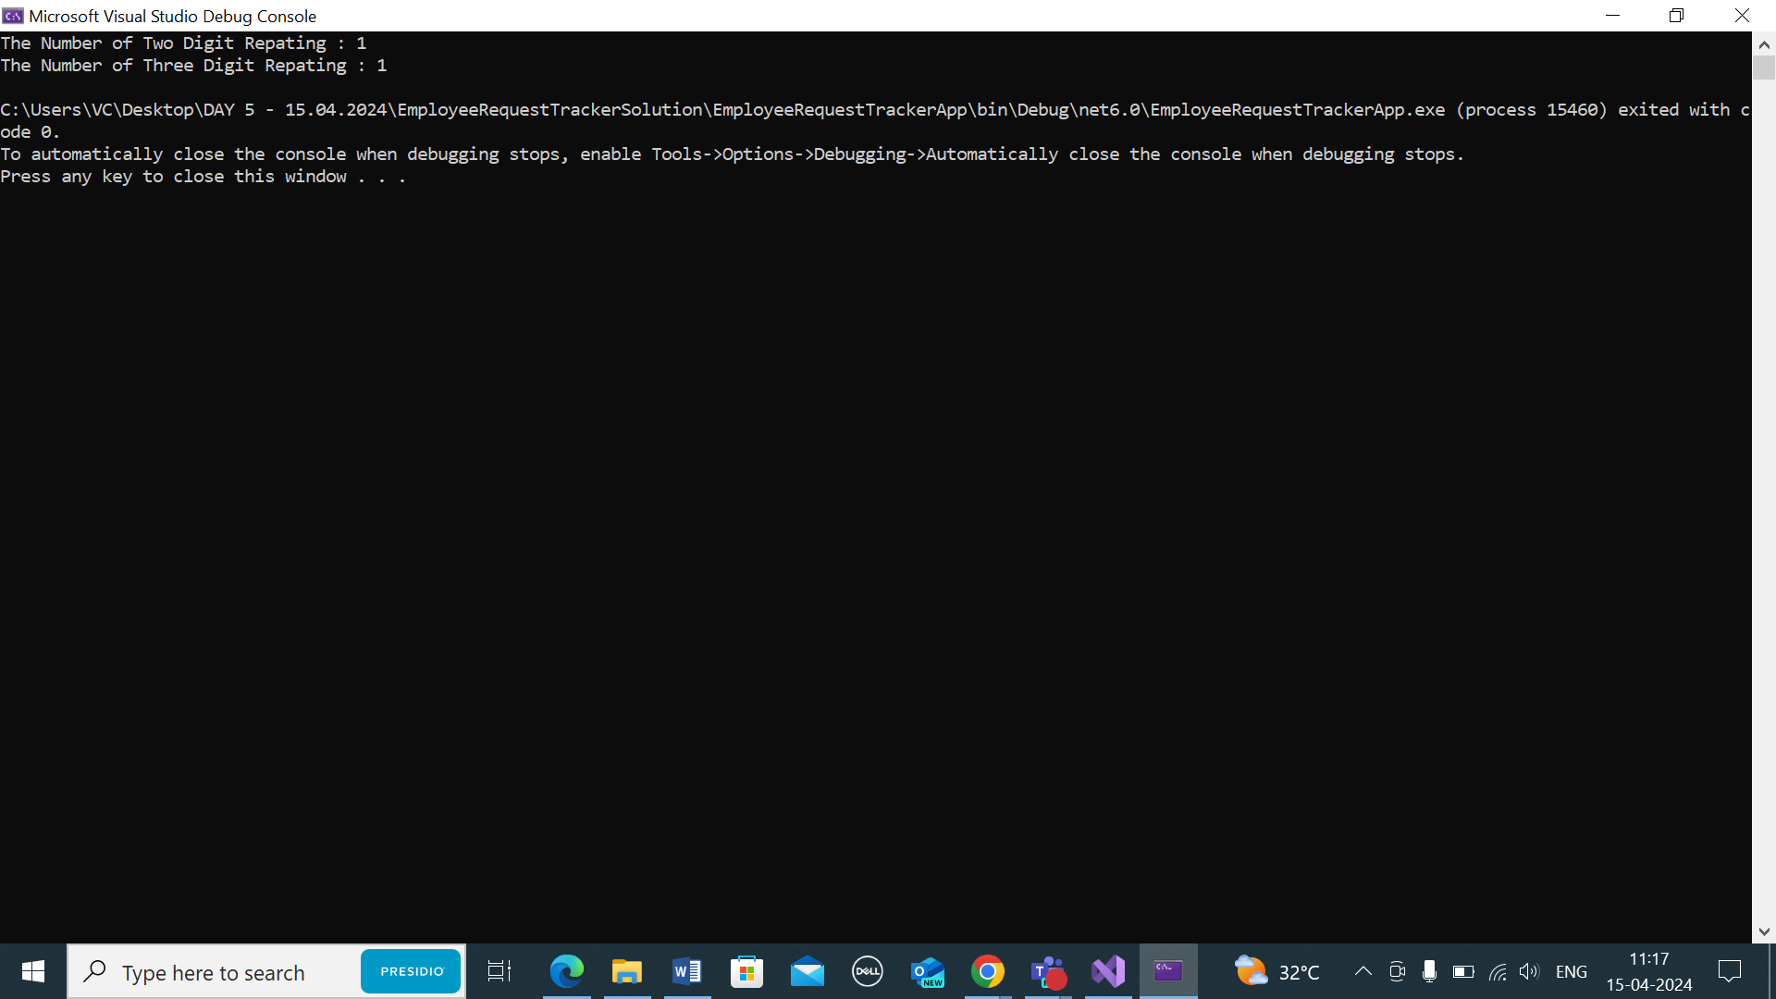

EMPLOYEE REQUEST TRACKER (MODEL LIBRARY) – EMPLOYEE OBJECT CREATION

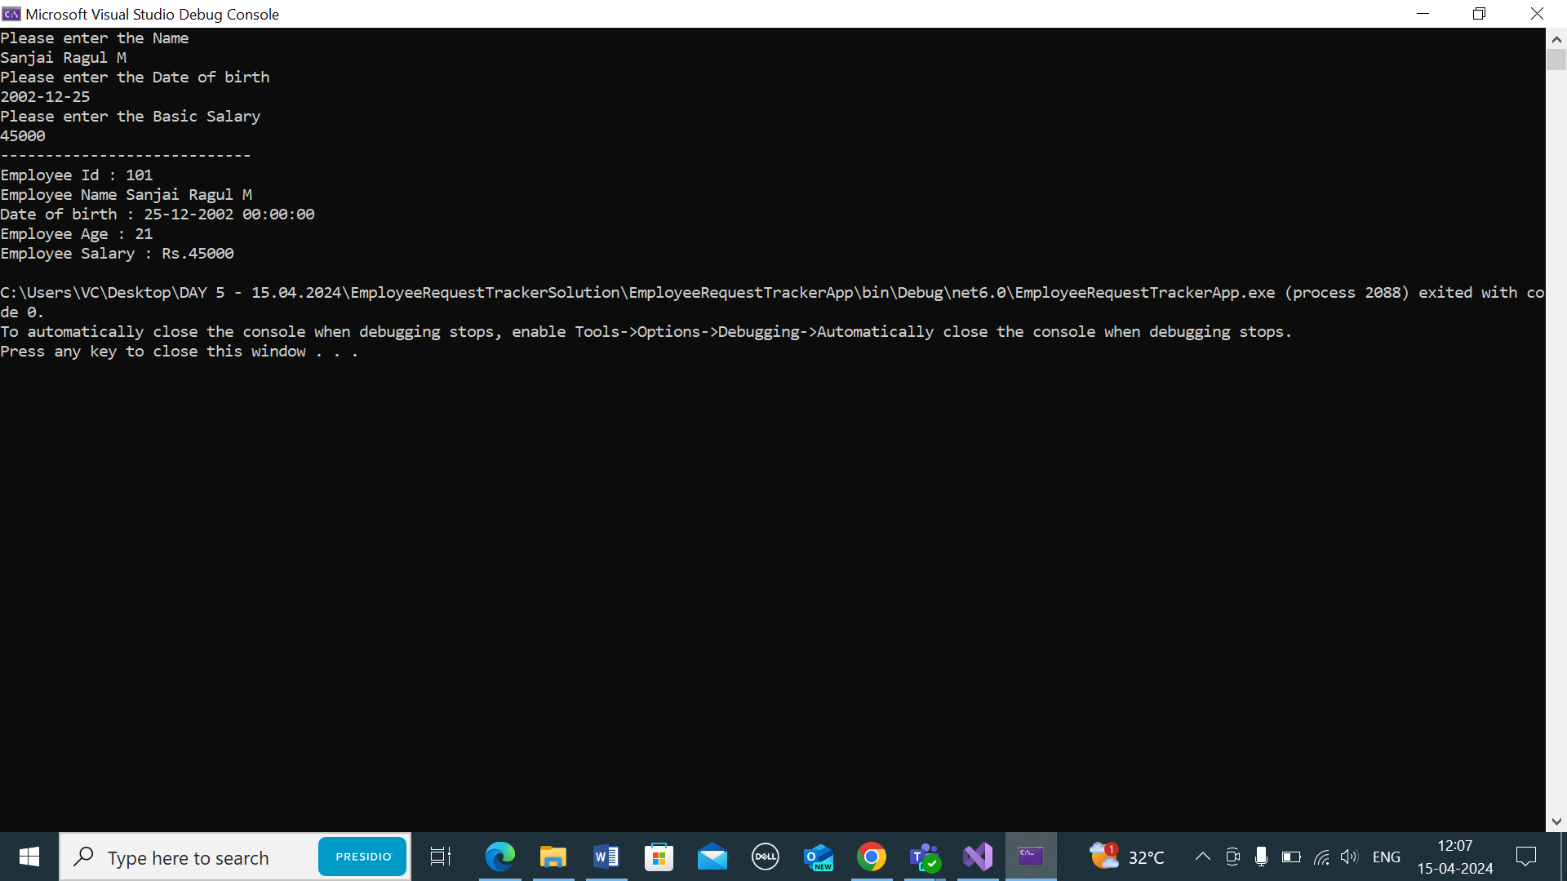

EMPLOYEE OBJECT CREATION AND PRINTING

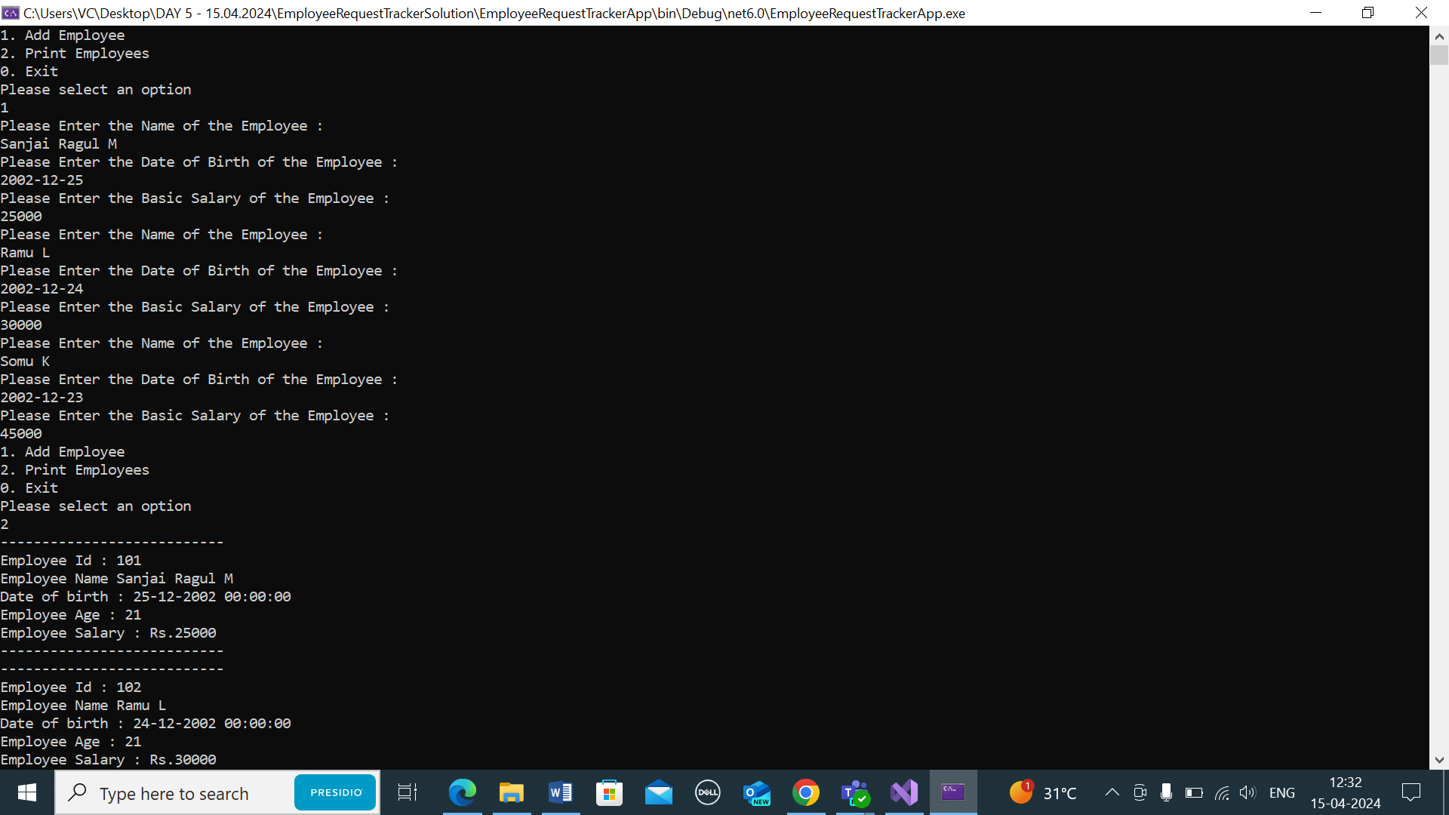

LEETCODE: COW BULL PROBLEM

